# UAT Test – Bug 3 report – assignment 4

## by Abhimanyu Bhat - 11732514

### Bug 3 – Incorrect calculation of fine owed in pay fine: -

|  |  |  |  |  |  |  |
| --- | --- | --- | --- | --- | --- | --- |
| **Test #** | **Description of tasks** | **Steps to execute** | **Expected results** | **Pass** | **Fail** | **Comments** |
| 1 | Checking whether the fines due to the patron are correct when checking PAY FINE. | 1. Add patrons to the database | Patron is created. | Yes |  |  |
|  |  | 2. Add books to the database (name, title, etc.) | Book entry is created. | Yes |  |  |
|  |  | 3. Take out a loan for a book | Book loan is taken out. | Yes |  |  |
|  |  | 4. Increment date to a date one day past due date using T | Date is incremented past due date. | Yes |  |  |
|  |  | 5. Return the book one day after due date | Book is shown to be overdue with fine amount. | Yes |  |  |
|  |  | 6. Paying the fine | Fine levied to Patron should be calculated correctly. |  | Yes | Fine is incorrectly calculated since it is shown to be double the actual amount. |

#### Screenshot of incorrect fine owed for one day:

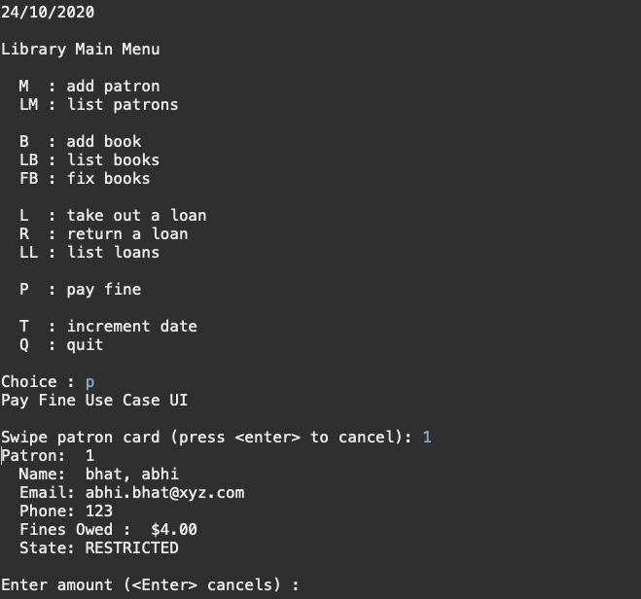

**Description of bug:**

Patron is overdue for returning a book by 2 days so his fine should be 2 dollars but when checking the “pay fine” option his fines owed is shown to be 4 dollars which is double the intended amount.

#### Screenshot of incorrect fine owed for three days:

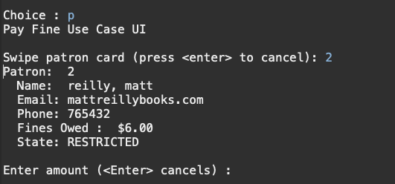

**Description of bug:**

Patron is overdue for returning a book by 3 days so his fine should be 3 dollars but when checking the “pay fine” option his fines owed is shown to be 6 dollars which is double the intended amount.

#### Screenshot of incorrect fine owed for five days:

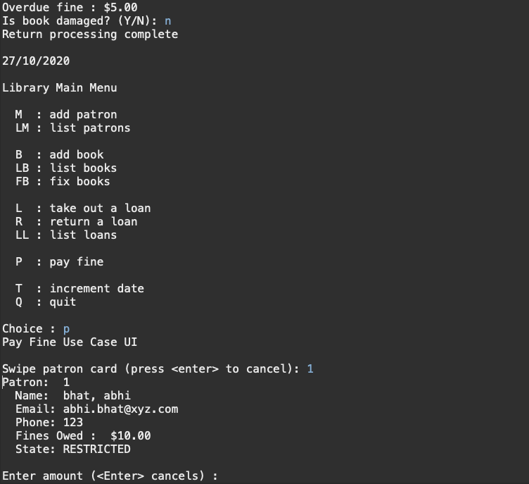

**Description of bug:**

Patron is overdue for returning a book by 5 days so his fine should be 5 dollars but when checking the “pay fine” option his fines owed is shown to be 10 dollars which is double the intended amount.

#### Screenshot of incorrect fine owed for four days:

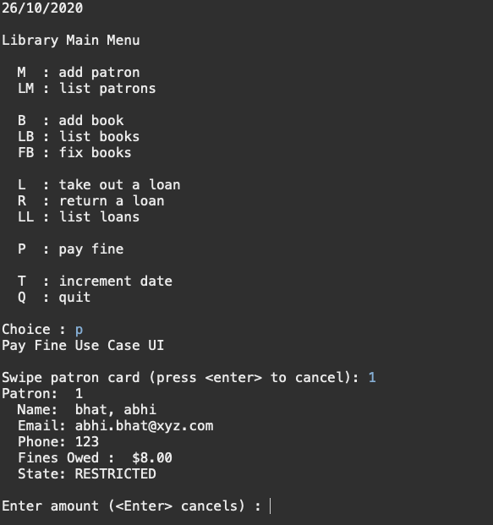

**Description of bug:**

Patron is overdue for returning a book by 4 days so his fine should be 4 dollars but when checking the “pay fine” option his fines owed is shown to be 8 dollars which is double the intended amount.